TCP Server
1. General
TCP Server permit to communicate to JTDX (Program based HF evaluation version by UA3DJY for Digital modes JT65, JT9, T10 and WSPR-2)
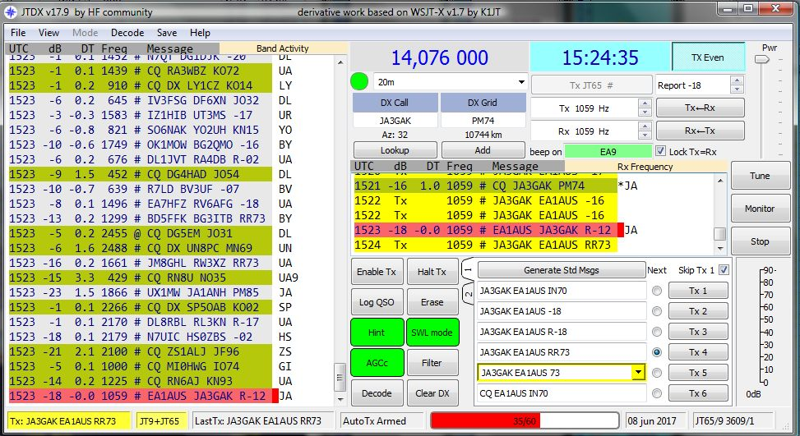
TCPS_1
This is a bridge between Logger32 and JTDX. When port of TCP Server is opened in Logger32, any QSO data of JT modes can be transferred automatically to Logger32 and Logger32 log this QSO in the current Logbook.
The following site is to download the last stable version of JTDX and online help.
http://jt65-dx.com/download/wsjtx-ua3djy.html
The following site is to download the last Beta version of JTDX. If user wants to run JTDX together with Logger32 then use this version.
https://www.facebook.com/groups/JTDX.HF.evaluation/

2. Configuration.
2.1 Configuration in Logger32
- Open the TCP Server from “View” option in main menu of Logger32.
Click File.
Click to Close Port : Click to close port or open port
Popup on connect:: The TCP Server window appears when it is connected to client if this option is checked.
Hide: Click to hide TCP Server window.

- 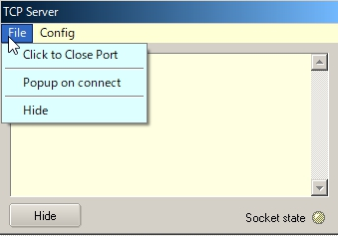

TCPS_2
Click Config to see the Host ID (PC name for this PC), IP address (for this PC) and port number.

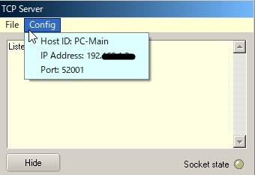
TCPS_3

Socket state LED show port/connection status .
Red: Port is closed
Orange: Port is opened but no connection established (or no connection request from JTDX)
Green: Connection established while JTDX is sending QSO data.

This status is displayed also in the lower status bar. Move cursor to TCP pane.
If the port is opened the text is highlighted with blue color. If the port is closed the text is highlighted with red color.

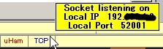

TCPS_3A

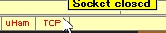

TCPS_3B

Right click on TCP pane to show menu.

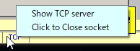

TCPS_3C

2.2 Configuration in JTDX

- JTDX may be installed not only in the same PC as Logger32 but diffrent PC if both PC are connected with LAN.
- Open the Reporting tab on JTDX settings, look for External logbook connection section. You see “127.0.0.1” as TCP Server and “52001” as TCP Port. These are default value.

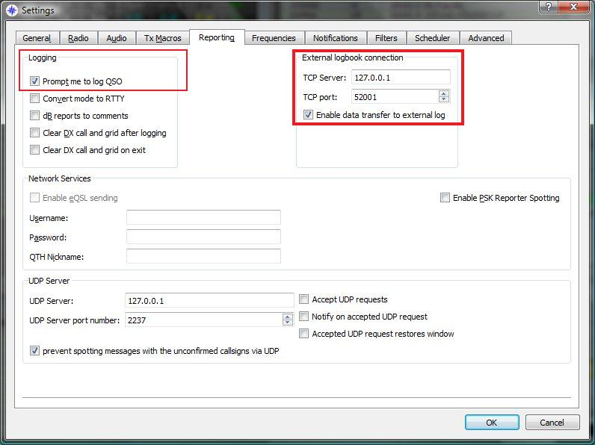

TCPS_4

- If JTDX is installed in the same PC as Logger32 then leave TCP Server as it is. Leave TCP port as it is.
- If JTDX is installed in the different PC then type IP address which you see in Logger32 TCP Server. (TCPS_3) Leave TCP Port as it is.
- Check "Enable data transfer to external Log" option.
- It's comfortable to check also "Prompt me to log QSO" in Logging section. In this way whenever we send a goodbye message, we will see the QSO data waiting to accept to transfer to logger32.
- Click OK to save settings.

Fields of QSO waiting to be transferred to Logger32.

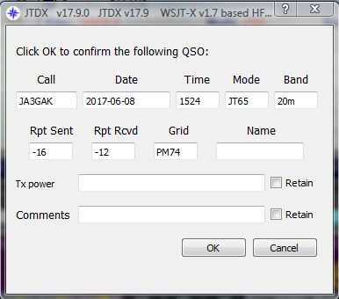
TCPS_5

3. Operation
a. Open TCP Server in Logger32 and open the port.(Next time you start Logger32, this action will be remembered)
b. Log QSO in JTDX. QSO data are displayed in blue text in the TCP Server window. This QSO is logged automatically in the current Logger32 Logbook. Example of traffic received through the TCP Server below.
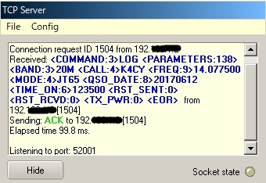
TCPS_6
4. Tips

4-1 Logbook synchronization

If you want to synchronize both Logbook in Logger32 and JTDX then try following steps. (This is suggested by Rick, VE7TK)

If your Logger32 logbook already contains JT65 and/or JT9 QSOs:

(1) In Logger32 export a PARTIAL log containing your JT65 and JT9 QSOs.
(2) Name the exported file wsjtx_log.adi and save it to a safe location.
(3) Replace the default wsjtx_log.adi file located in c:\user/name/AppData/Local/JTDX with the new file exported from Logger32.

Importing the data from YOUR Logger32 logbook will ensure that JTDX has updated DXCC / Mode and QSO data and will flag the calls heard correctly.

4-2 Connection error

If you have JTDX error message "Socket operation timeout" or "Host not found" then try following steps.

(1) Close/Open TCP port
(2) Look at IP address displayed in Config menu and lower status bar. Type this IP address in JTDX TCP Server box.

